Software Engineering:  
Lemon Notes

**Members:**

Mike Cavataio

Alex Kouthoofd

Michael Kolacki

**Project Overview:**

The primary functionality of Lemon Notes/The Inter-Shell is to provide the user with a convenient and comprehensible means of making and storing easily accessed and multifaceted personal notes. Secondary functionality should provide rudimentary web-services to the user which may, if desired, be incorporated into personal notes. The user should be provided the option of storing these notes either locally on their computer in a specified file location, or in the cloud if the user’s information is provided and an internet connection is capable of being established. Core functionality of Lemon Notes should not be dependent on the establishment of an internet connection. Offline capabilities of and services provided to the user must include, but are not limited to:

* An aesthetically pleasing interactive display consisting of a notepad portion which shows the note being written currently, and an easily navigated toolbar which indicates the current project notes are being taken on, and which provides several capabilities to the user, including but not necessarily limited to:
  + The ability to access other projects.
  + The ability to minimize the display.
  + The ability to exit the application.
  + The ability to maximize the screen, which has the added feature of displaying all previously taken notes for the current project on a scrollable screen with their respective times of recording and the ability to highlight or remove previous notes.
  + The ability to access an options pulldown menu which allows the user to adjust font settings, color settings, internet settings, the ability to open the application on startup, access to a help/information screen, the ability to have the display always visible on the screen, and ideally but not crucially the option to add/edit modes and the ability to sign in to or out of their own personal cloud (given that an internet connection may be established).

Also accessible to the user form the main display should be a button to preview the current note in the specified mode, a button to add the current note, a button to clear the screen so that only the current note is displayed, and a button to show the timestamps of the 5 most recent notes for the current project which, when clicked, will be displayed on the screen.

* The ability to take notes in any of several easily used “modes”, ranging from things like a basic calculator where notes taken as operations are calculated and the results recorded, to a citation mode where the user need only plug in information to a formatted note to cite something in a desired template.

Ideally, there will also be a mode allowing the user to run executables while offline.

Online capabilities and services should include, but are again not limited to:

* A large increase in the number of available modes, including the ability to:
  + Conduct a search on what would ideally but non-crucially be a configurable search engine. The top 5 results of said search should be displayed next to the main display, where the 5 most recently added notes would generally be accessible.
  + Browse the web for some specified website which, if said website exists, will open the user’s default browser and open said website.
  + Get the user’s current location, or some other specified location and show a map of the area.
  + Make a plot of some function.
  + Conduct a search on YouTube for whatever the user desires.

If possible, and if desired by the user, results obtained from these modes should be able to be incorporated into notes.

* Ideally but non-crucially access the user’s personal cloud should they provide their information in order to make their notes more accessible and to free up space on their computer.
* Ideally but non-crucially interact with other users of Lemon Notes to have collaborative projects with permissions on who is able to access them.

**System Requirements:**

Based upon consumer needs, a list of requirements for the application has been derived. For features that must be implemented by the application, we state that "The user/application shall," whereas for features that would ideally be included but are not "mandatory," we state that "The user/application should". For each requirement, we assign an identifier and number in the form of IDENTIFIER-# as well as a priority weight from 1 to 5. A higher priority weight indicates that the corresponding requirement is more essential to the success of the project, and more critical to fulfilling the customer’s needs.

**Functional Requirements:**

|  |  |  |
| --- | --- | --- |
| Identifier | Priority | Requirement |
| REQ-1 | 5 | The user shall be able to make a note which is then stored to a designated file location. |
| REQ-2 | 5 | The user shall be able to close the application, and upon doing so have any uncommitted notes be saved and available upon re-opening the application. |
| REQ-3 | 5 | The user shall be able to access and observe the 5 most recent notes for the current project. |
| REQ-4 | 5 | The user shall be able to have and create multiple projects at any given time. |
| REQ-5 | 5 | The user shall be able to access and adjust preferences for the application including font settings, color settings, and themes. |
| REQ-6 | 4 | The user shall be capable of performing several mode-specific operations regardless of connection to the internet, such as basic calculations and citation assistance. |
| REQ-7 | 4 | The user shall be capable of performing a number of further mode-specific operations should they be connected to the internet, such as conducting several different searches, browsing for specified sites, and getting location information. |
| REQ-8 | 4 | The user shall be able to preview any note, especially a formatted note before adding it. |
| REQ-9 | 3 | The user shall be able to view all previous notes for the current project when the screen is maximized. |
| REQ-10 | 3 | The user shall be able to delete a previously made note. |

**Non-Functional Requirements:**

|  |  |  |
| --- | --- | --- |
| Identifier | Priority | Requirement |
| REQ-11 | 5 | The application shall be easily navigable, not necessitating that the user spend an inordinate amount of time searching to find the desired menu/information. |
| REQ-12 | 5 | The application shall be intuitive to use, with making and previewing notes being able to be done quickly, and with modes being instinctively initiated. |
| REQ-13 | 3 | The application shall have clear and concise descriptions of each of the modes, containing information about what they are, what they do, and how they’re initiated. |
| REQ-14 | 3 | The application shall not be overbearing on the user’s screen, ensuring that the app is helpful and not hindering. |
| REQ-15 | 3 | The user shall not find that the application causes unexpected, noticeable impacts on system performance. |
| REQ-16 | 2 | The user should find the application provides adequate support for those who have difficulty reading. |
| REQ-17 | 2 | The user should find the app aesthetically pleasing. |

**On Screen Appearance Requirements:**

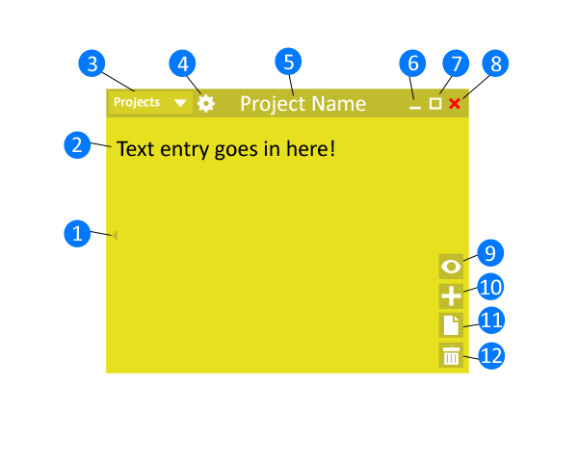  
**Figure 1: Application Main Screen**

The main screen of this application provides access to several different features. These features are numbered and illustrated in Figure 1 above. This includes a button to display the several most recent notes (1), the primary notepad where notes are taken (2), a dropdown scrollable menu displaying all of the user’s alphabetized projects (3), a dropdown menu providing the user access to application settings, information, and preferences (4), the name of the currently open project (5), buttons to minimize, maximize, and exit the application window (6, 7, and 8), a button to preview the current note in the indicated mode (9), a button to add and save the current note to the respective project (10), a button to clear the notepad without adding or deleting the current note (11), and a button to delete either the current note or a selected note that has been made previously (12). The features indicated by number 1 is illustrated further in Figure 2 below.

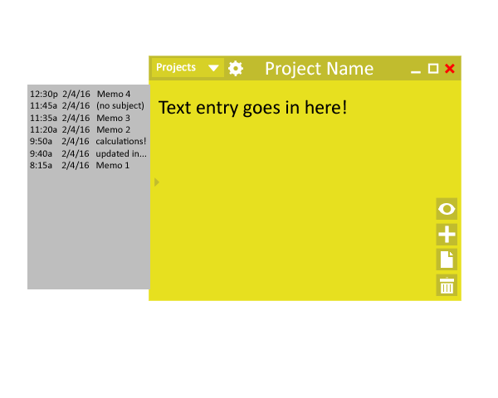  
**Figure 2: Previous Notes**

The grey screen illustrated in Figure 2 is brought up by clicking the button denoted by the number 1 in Figure 1 and shows in chronological order previous notes for the current project, with the more recent notes appearing higher up the list. Items on the list are headed by a timestamp and/or the subject of the note.

**User Stories:**

|  |  |  |
| --- | --- | --- |
| Identifier | User Story | Size |
| ST-1 | As a note taker, I can write and save a note to the appropriate location. | 2 Points |
| ST-2 | As a note taker, I can close the application whenever I so desire, and should I forget to add the current note, I can see it again when I re-open the app. | 2 Points |
| ST-3 | As a note taker, I can easily navigate the application. | 4 Points |
| ST-4 | As a note taker, I can easily see and manipulate at least my 5 most recently taken notes. | 4 Points |
| ST-5 | As a note taker, I can have and create multiple projects at will. | 3 Points |
| ST-6 | As a note taker, I can adjust the visual settings, including font settings, color settings, and the theme settings. | 5 Points |
| ST-7 | As a note taker, I can perform a number of operations on my notes dependent on an easily indicated mode, regardless of connectivity to the internet, with more modes being available if a connection is able to be established. I can also find and see what modes are available and how to initiate them. | 8 Points |
| ST-8 | As a note taker, I can preview what my note looks like in the current mode before adding it, with previewing being quick and easy. | 7 Points |
| ST-9 | As a note taker, I can see all of my previous notes for my current project when I maximize the window. | 6 Points |
| ST-10 | As a note taker, I can delete a note I made previously. | 5 Points |
| ST-11 | As a note taker, I should be able to sign into and out of my own personal cloud. | 8 Points |
| ST-12 | As a note taker, I should be able to run executables on my computer. | 8 Points |
| ST-13 | As a note taker, I should be able to interact with other users of the app in order to collaborate on projects, and I should be able to set permissions on those projects so only those I desire can access them. | 10 Points |

**Use Cases:**

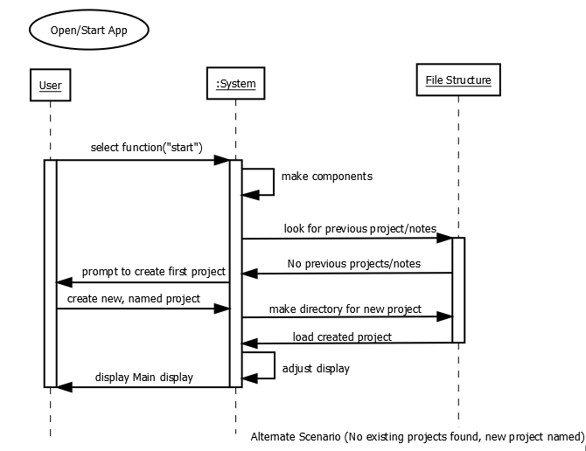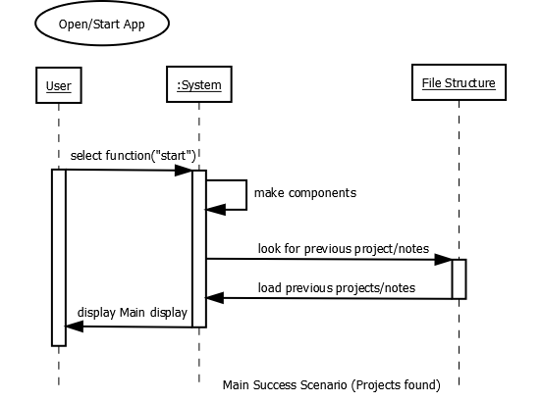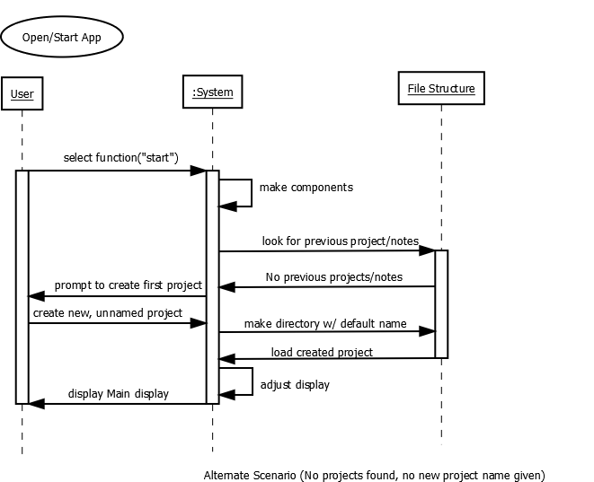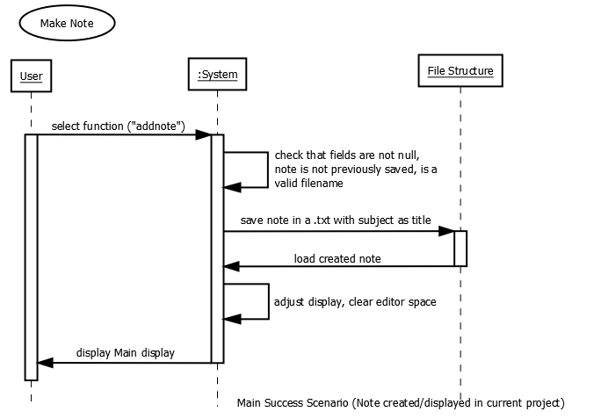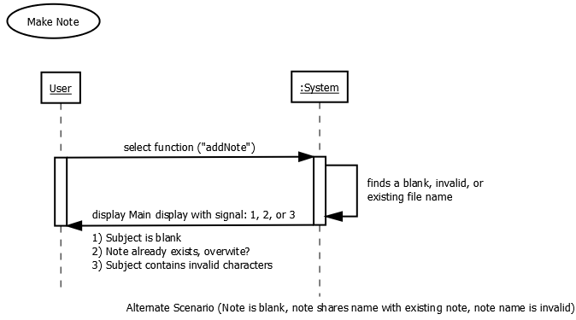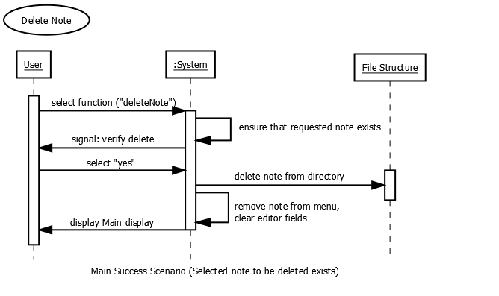

Use Case: Delete Note

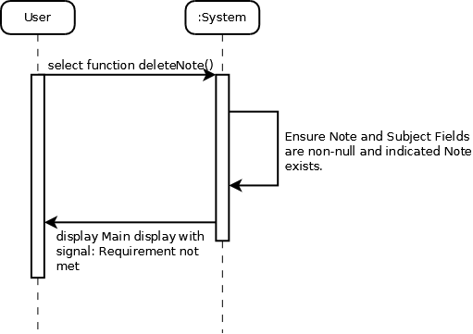

Alternate Scenario (No subject/Field, No Existing Note)

Use Case: Delete Note

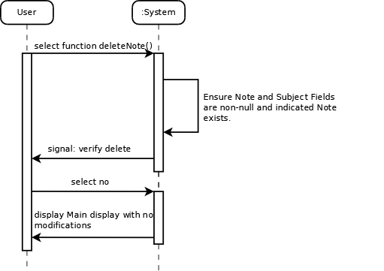

Alternate Scenario (Note present, but Delete function not Desired)

Use Case: Observe Old Notes

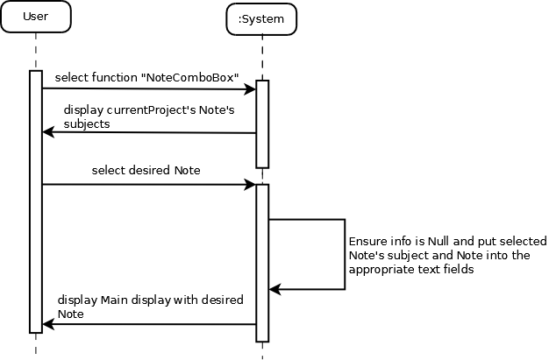

Main Success Scenario (Display Old Note, no Current Note)

Use Case: Observe Old Note

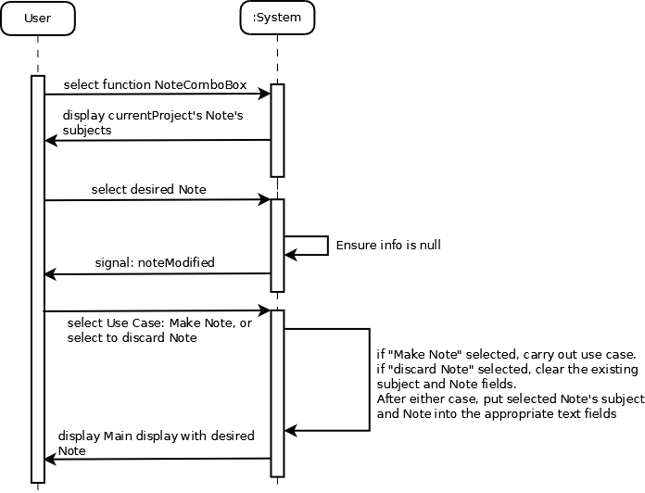

Alternate Scenario (Display Old Note, current Note present and either Saved or Discarded)

Use Case: Select Project

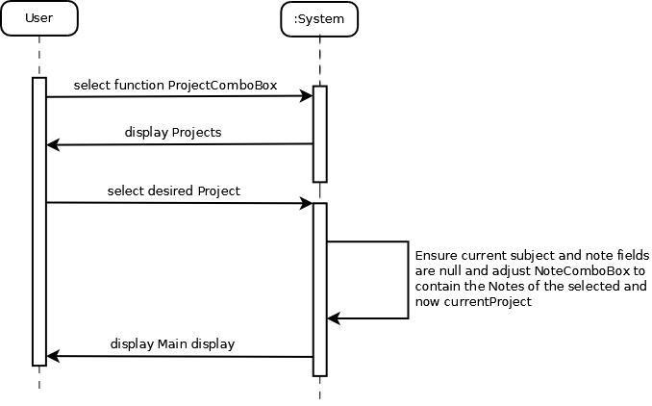

Main Success Scenario (Switch Current Projcect, no Current Note)

Use Case: Select Project

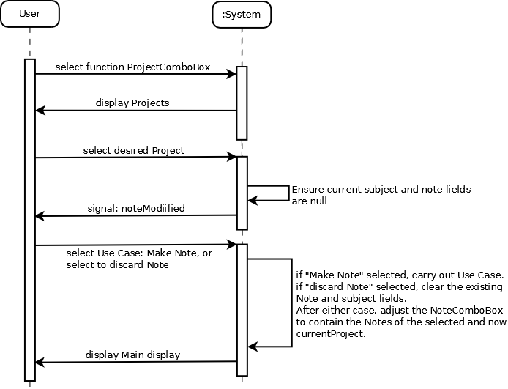

Alternate Scenario (Switch Current Project, Current Note present and either Saved or Discarded)

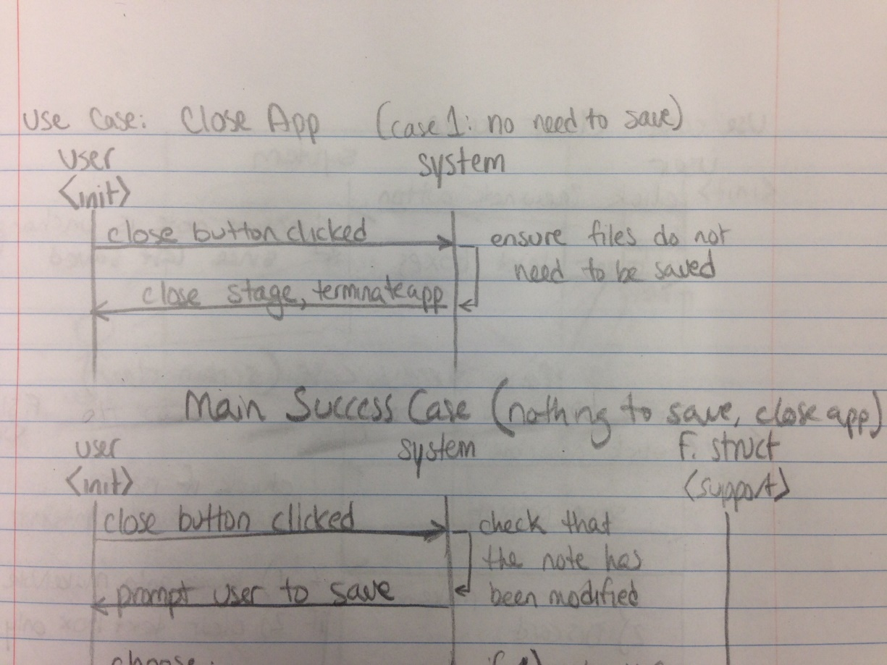

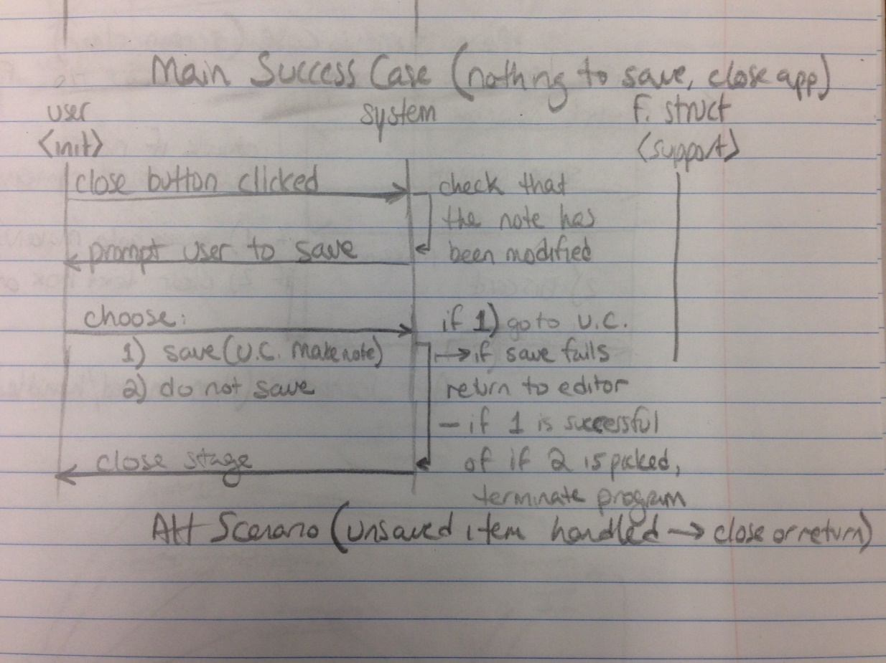

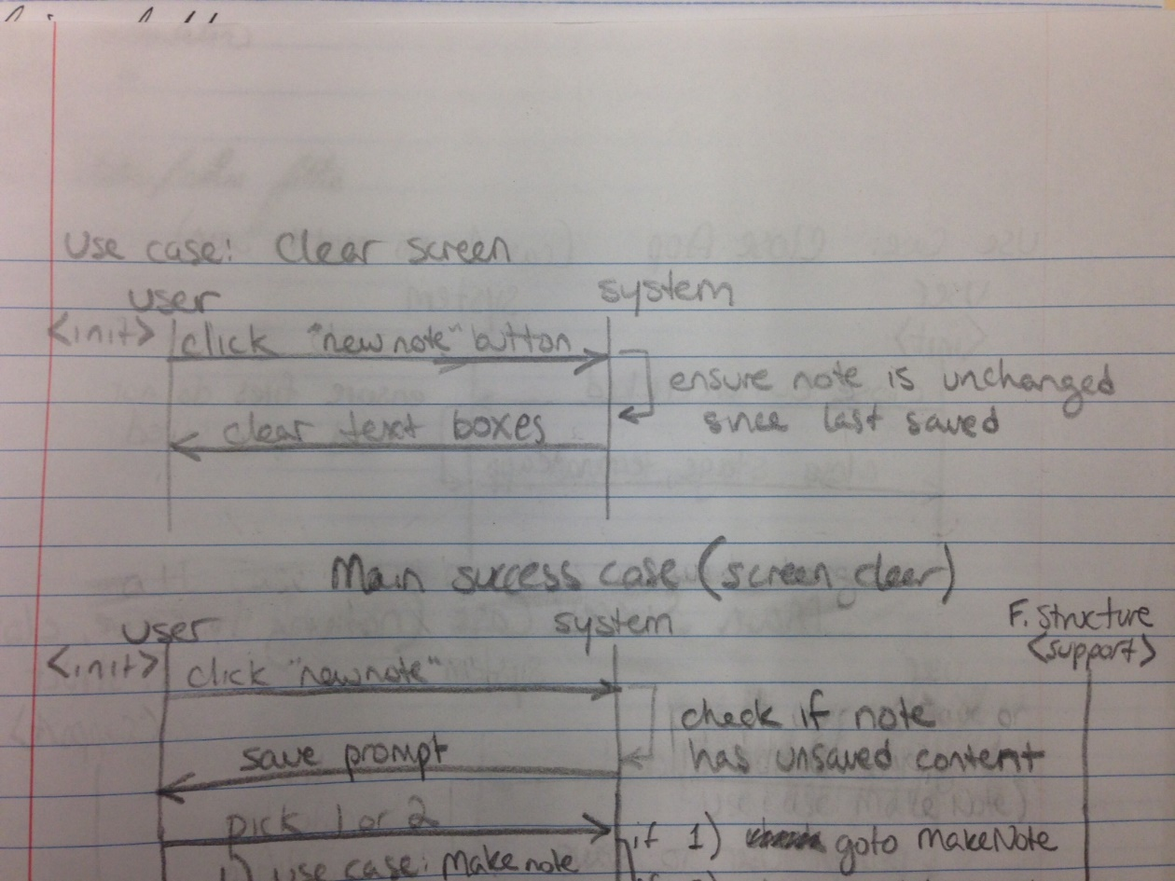

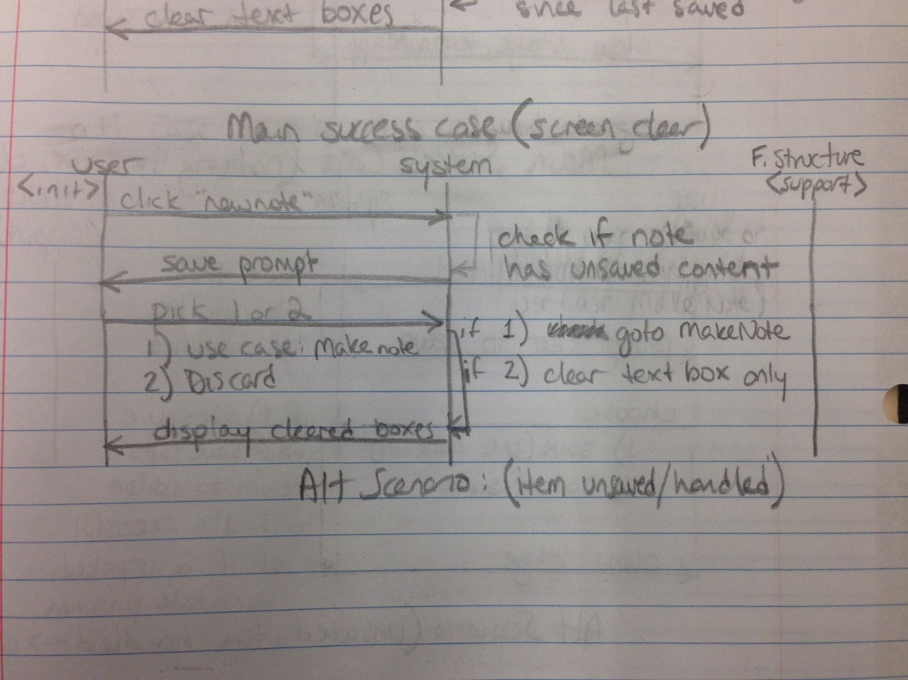

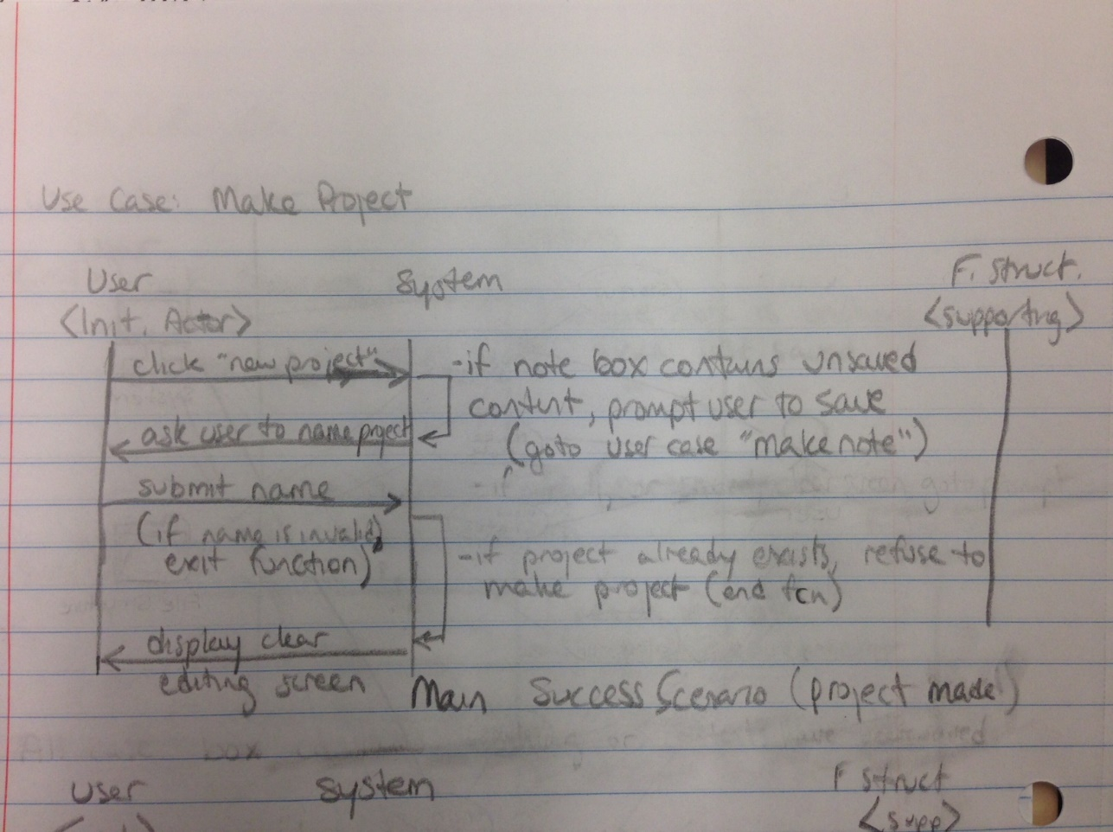

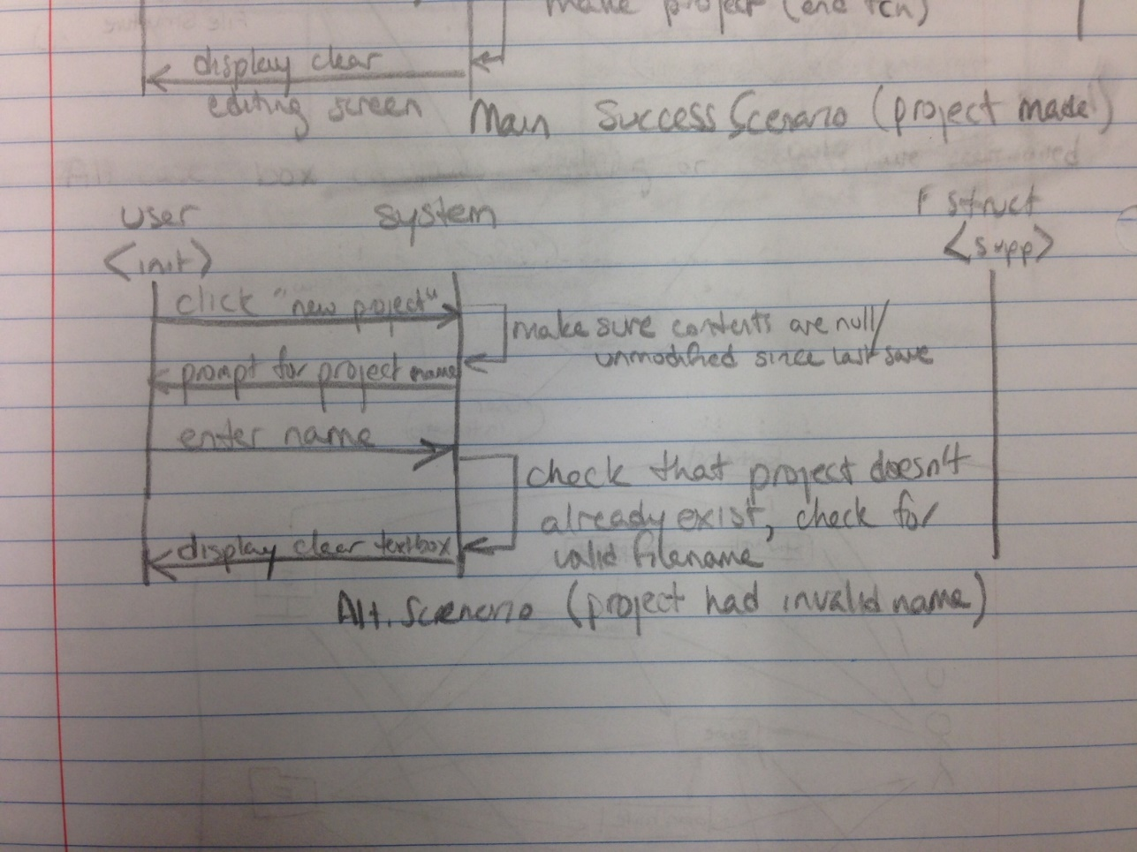

|  |  |  |
| --- | --- | --- |
| **Actor** | **Goal** | **User Case** |
| Note Taker,  System, File Structure | Initialize the application, starting with checking for the Projects directory’s existence. If there are no existing projects, prompt the user to make a project (U2). Otherwise, display the editor. | Start-Up (U1) |
| Note Taker, System, File Structure | Add a new item to the Projects directory, where all notes in the project will be stored. | Create Project (U2) |
| Note Taker, System, File Structure | Save the note to the directory of the project being edited. | Make Note (U3) |
| Note Taker, System | Change the project being edited to the selected project. | Switch Project (U4) |
| Note Taker, System | Clear the editor screen. If the editor has unsaved changes, save the note (U3). | Clear Screen (U5) |
| Note Taker, System, File Structure | Remove the current note from the project. | Delete Note (U6) |
| Note Taker, System, File Structure | Read the contents of the selected note and displays it in the editor. | Open Note (U7) |
| Note Taker, System | Shut down the application. If there are unsaved changes in the current note, prompt the user to save. (U3) | Close App (U8) |
| Note Taker, System, File Structure(?) | Parse the plain-text mode filters used in the editor and display the note with the desired formatting. | Preview Note (U9) |
| Note Taker, System, File Structure(?) | Change the appearance of the editor for accessibility purposes. These settings should be persisted across user sessions. | Adjust Settings (U10) |

|  |  |  |  |  |  |  |  |  |  |  |  |
| --- | --- | --- | --- | --- | --- | --- | --- | --- | --- | --- | --- |
| Req't | PW | U1 | U2 | U3 | U4 | U5 | U6 | U7 | U8 | U9 | U10 |
| 1 | 5 | x |  | x |  |  |  |  |  |  |  |
| 2 | 5 |  |  | x |  |  |  |  | x |  |  |
| 3 | 5 |  |  |  |  |  |  | x |  |  |  |
| 4 | 5 | x | x |  | x | x |  |  |  |  |  |
| 5 | 5 |  |  |  |  |  |  |  |  |  | x |
| 6 | 4 |  |  | x |  |  |  | x |  | x |  |
| 7 | 4 |  |  |  |  |  |  | x |  | x |  |
| 8 | 4 |  |  |  |  |  |  |  |  | x |  |
| 9 | 3 |  |  |  |  |  |  | x |  |  |  |
| 10 | 3 |  |  |  |  | x | x |  |  |  |  |
| Max PW | | 5 | 5 | 5 | 5 | 5 | 3 | 5 | 5 | 4 | 5 |
| Total PW | | 10 | 5 | 14 | 5 | 8 | 3 | 13 | 5 | 12 | 5 |